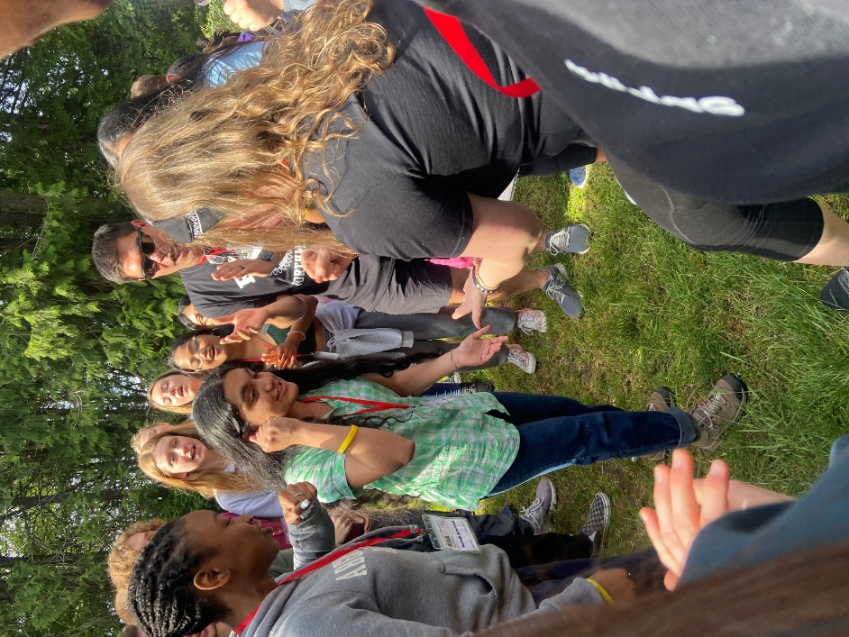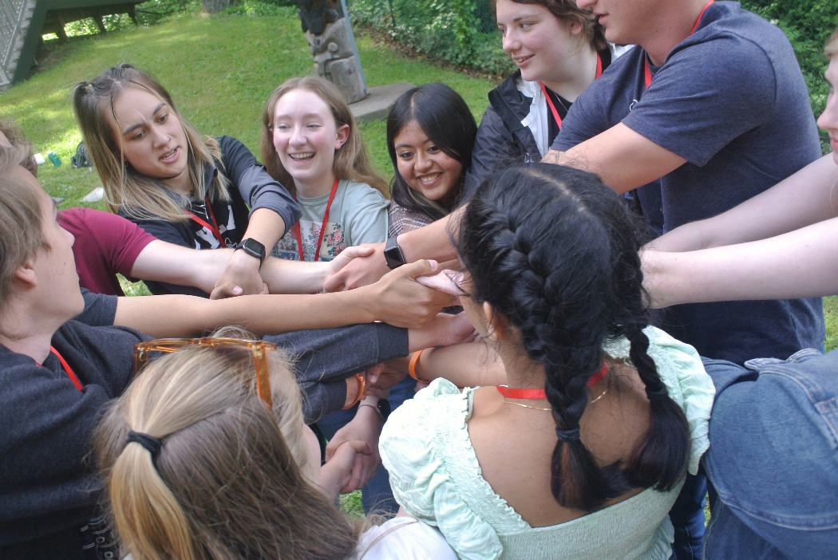

|  |  |  |
| --- | --- | --- |
| Video C:\Users\Kate\Downloads\Screenshot_2022-12-08-19-42-49-86_e2d5b3f32b79de1d45acd1fad96fbb0f.jpg | Z:\Kate\Rotary\RYLA\RYLA PNW\Logo\Logo 2021.JPG | C:\Users\Kate\AppData\Local\Microsoft\Windows\INetCache\Content.Word\7572518542891341609.jpgBrochure |

The next Rotary Youth Leadership Award (RYLA) Northwest will be June 5-8 at YMCA Camp Colman. Since 1969, we've had the honor and privilege to teach leadership development to over 5700 students. We're seeking student candidates who are willing to step outside their comfort zones to become servant leaders (individuals who advance the growth and well-being of people and the communities to which they belong).  All students must be in grades 10 or 11, below age 18 at the time of the conference.

For more information, contact:

